Wind Turbine Logic Game (solution)

Professor Max Powers has decided to build a wind turbine but doesn’t know
what style would be best. He enlists the help of 4 students. Each student
comes up with a different blade shape and number of blades. They brought
him their designs, but he has dropped the folder and needs your help piecing
it back together. Use the clues below to match the student, blade number,
and blade shape.

Clue 1: Either Ariel or the turbine with 4 blades has blade shape B
Clue 2: Wendy designed blade shape A
Clue 3: Wattson’s design, the design with 4 blades, and blade shape D are 3 different designs.
Clue 4: Of the designs with 4 blades and design B, one is Ariel’s and the other is Wendy’s.
Clue 5: Wattson’s design has 2 more blades than Ariel’s design.

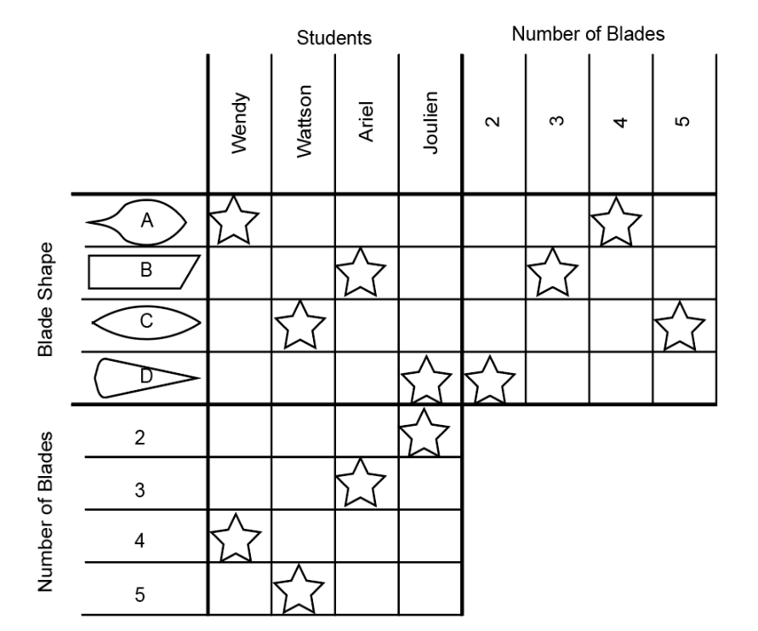

Hint: place an X in any box that cannot be true and a star in any box that must be
true. Anytime a star is placed, X’s can be placed in all other boxes in that column
and row.
Example 1: when a star is placed based on the clues, X’s can be placed in all the
other boxes in the row and column
Example 2: Completed puzzles should look like this.

